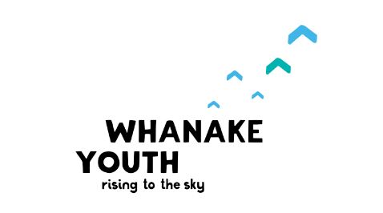
Whanake Youth
PO Box 2004
Stoke 7041
Nelson

whanakeyouth.org.nz
jess@whanakeyouth.org.nz

021 655 231

Dear volunteers,
Whanake Youth offers a free service to young people from the ages of 13 - 17 called Wicked Tooth Fairy to provide free transport and support in getting young people to a dentist.
The reason we are doing this, is because there are over 1000 young people in the community that do not access the free dental service. We know life is busy and that dental care can be a bit scary for some, we’re here to help!
Who is Whanake Youth?
Whanake means to rise up to the sky, to move onwards, to spring up, develop and to grow. Our mission is “to empower youth to participate and lead their journey from adolescence to adulthood, with the support of their whanau and community.” Check out our website www.whanakeyouth.org.nz for more information.
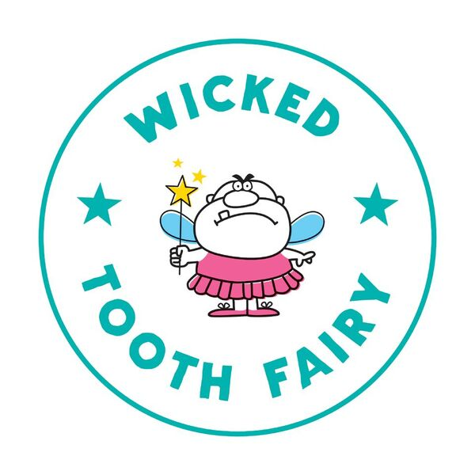
Details of the Wicked Tooth Fairy Service:
Volunteers, who have their full license, been police vetted and trained, will be picking up to six young people and taking them to dentist appointments. They can help with filling out forms, answering questions, calming nerves and assisting on arrival.
Who can use the service?
Young people from Nelson/Marlborough regions who fit the criteria (under the age of 18 years, have not accessed a dentist in the last 12 months, or not enrolled with a dentist).
Volunteers:
We need volunteers that are over the age of 18, can complete police checks and provide references, and are available during the week between the hours of 9am – 3pm.
Appointments will be made to best suit the young person, so they could be any time during the day and often last for an hour or so. The volunteer would need to collect the young person from school, take them to the dentist that they have an appointment with, help with any paperwork that they may need to fill out, and either support them in the dental room or wait for them in reception. Once the young person has finished their appointment the volunteer will assist them to make any further appointments and will need to return the young person to school and ensure that they have signed back in.
Volunteers will then contact Jess van Arendonk at Whanake Youth to inform her of any further bookings or any information that is important to report.
Whanake Youth has the use of a manual van that volunteers can access for these appointments, or if volunteers would prefer, they can use their own vehicles and be reimbursed for mileage.
If you have any further questions, please contact Whanake Youth via the email address above or through the website. We look forward to working with you.

Kind regards,

Jess van Arendonk
Wicked Tooth Fairy project lead

