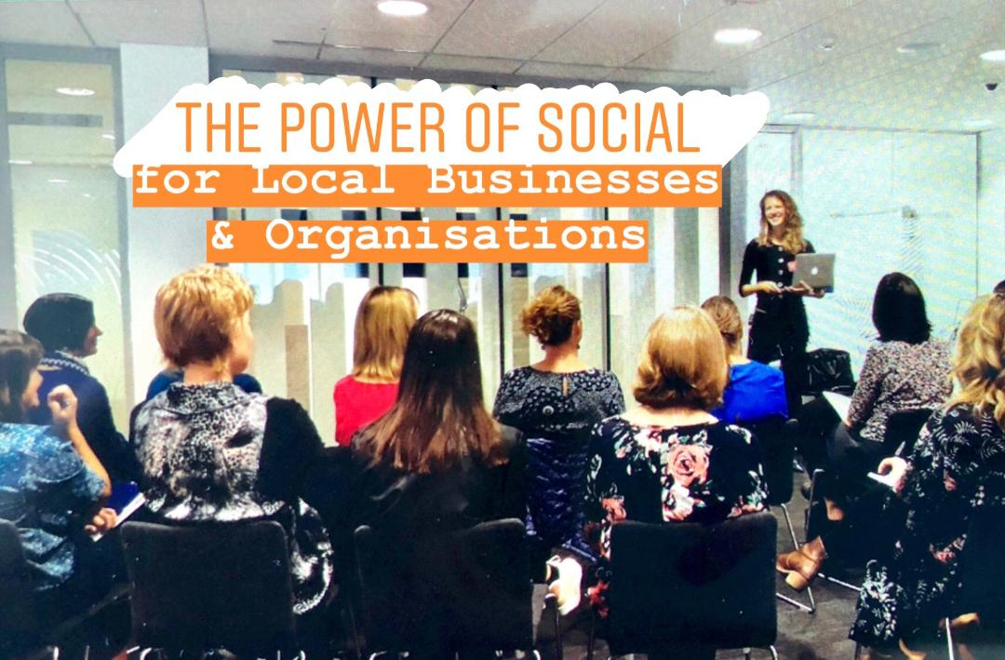

Where? - St Barnabas Foyer, 523 Main Road Stoke Nelson
When? – Thursday November 28th 5.30 – 7.30pm
Light refreshments provided
A chance to familiarise yourself with how to use social media for local businesses and organisations, with a focus on leveraging local events in the community. This will be an intro level event where we will cover the basics of social media marketing together with some practical tips

To register please click on the link

https://events.humanitix.co.nz/the-power-of-social-for-business-and-organisations

