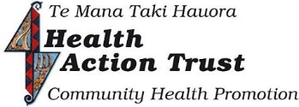
&
Peer Support & Advocacy Service
We are now located at
86 Selwyn place Nelson (Upstairs)

