Working with Clients with Anxiety:
A simple model for helping your clients overcome Anxiety and Overwhelm
Thursday 18th October, 9.30 – 4.30 p.m. – Fairfield House, 48 Van Diemen Street, Nelson
Tuesday 23rd October, 9.30 – 4.30 p.m. – Meeting Room 6, St Andrews, 5 Henry St, Blenheim

$189.

Includes lunch, handouts, plus six week’s access to 3 hours of video presentations from Angela’s latest on-line courses - ‘The Defrag Action Plan’ and ‘The Upward Spiral Action Plan which cover many of the key concepts from this workshop.

To register go to www.thechangeacademy.co.nz

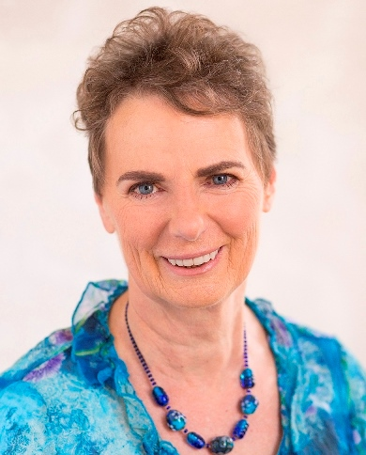
Target Audience: Counsellors, Social and Community Workers, Youth Workers, Educators, Pastoral-care Workers, Nurses, and other allied professionals.

Presented by Angela Baker, (Registered Counselling Psychologist). Angela worked at the Student Counselling Service at Massey University for over 12 years. She is currently in private practice offering counselling, coaching and supervision as well as offering on-line courses on Mindfulness and managing stress, and face-to-face workshops on topics related to Wellbeing.

About The Workshop
- Angela presents a simple, evidence-based model that clients can easily relate to
- This model is a helpful way to introduce clients to relevant neuro-science and psycho-physiology in terms they can easily understand and make use of
- Integrates well with a wide range of counselling modalities
- The approach is very practical – Angela will demonstrate how she uses this model in a counselling session in a way that is ‘experience near’ for clients, helps them to understand they’re not going crazy and are not ‘broken’, and introduces them to practical strategies they can integrate into their daily lives
- This model weaves in very effectively with creating a practical ‘Wellbeing and Resilience Action Plan’ with your clients over successive sessions (sample format provided).

Comments from previous ‘Working with Clients With Anxiety’ workshop “Well organised and presented material. Easy to absorb, well-paced and generous sharing of your resources and knowledge.” “The practical suggestions for working with anxiety were a useful addition to my toolkit as well as for taking care of myself.” (Garry, Fieldworker) “Great to watch your interview with a client (role-play) and teaching at the whiteboard. Clear, practical, information, strategies and techniques to change my practice positively.” (Shirley Jourdain, Counsellor)

A comment from a lecturer who showed one of Angela’s videos, presenting this model, to her class. “…My colleague H…was 'blown away' by your presentation on stress and the mind. He's heard some of that information from other sources, but never so well collated and exemplified. He said it should be a TED talk. He (and I) are deeply grateful for you letting us hear the talk.”

To register: Go to www.thechangeacademy.co.nz

