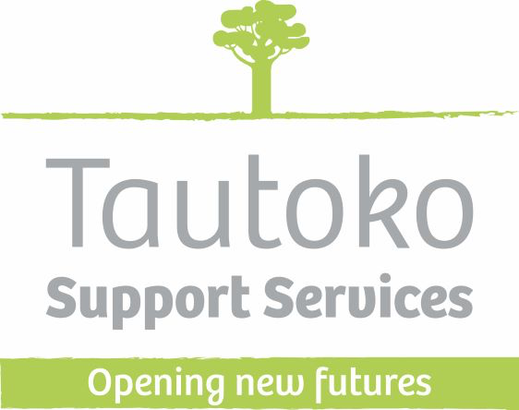

We’re Hiring!
Do you want to work in a friendly, professional, supportive organization?
Be part of a self-managing team who can make their own decisions?
Work for a charitable organization who put people first.
Do you want to make a difference to the people receiving support?
Are you available to work flexible hours?

What we do
Options offers person centred support to enable people to live the lives they choose and work towards their goals and dreams.

How we work
We approach our work with understanding and empathy, walking alongside people as they develop and grow.
You don’t need to have previous experience in this field, nor do you need qualifications – we’re happy to support you to become an excellent team member and obtain a qualification in health and wellbeing. Above all we want someone that shares in our values. These are:

Our Values
Whakapapa - Understanding, empathy, to walk alongside.
Whanaungatanga - Inclusion to bring people together
Manaakitanga - Build on the strength’s, abilities and skills of the person and of the people in their lives
Whakaaroaro - To ponder, consider carefully, give thought to, reflect on
Ahurutanga - Create a safe place to be part of

How we will support you?
Regular team meetings
You will be part of an excellent supportive team
Access to up to date, relevant training and the ability to gain a qualification in health and wellbeing
Regular catch ups with a Team Leader to review what’s working and what’s not working
Support to develop your own ‘one-page profile’ so that the team will know what is important to you and how you like to be supported

If this sounds like you then please email: mariecalderbank@tautoko.org.nz telling me why you are interested and we will set up a time to talk.

www.tautoko.org.nz

