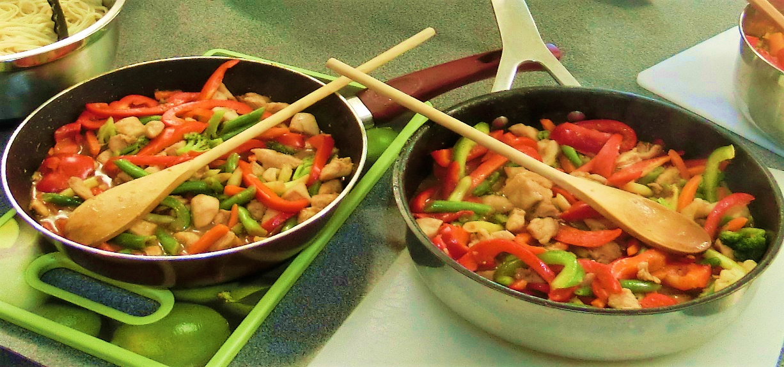
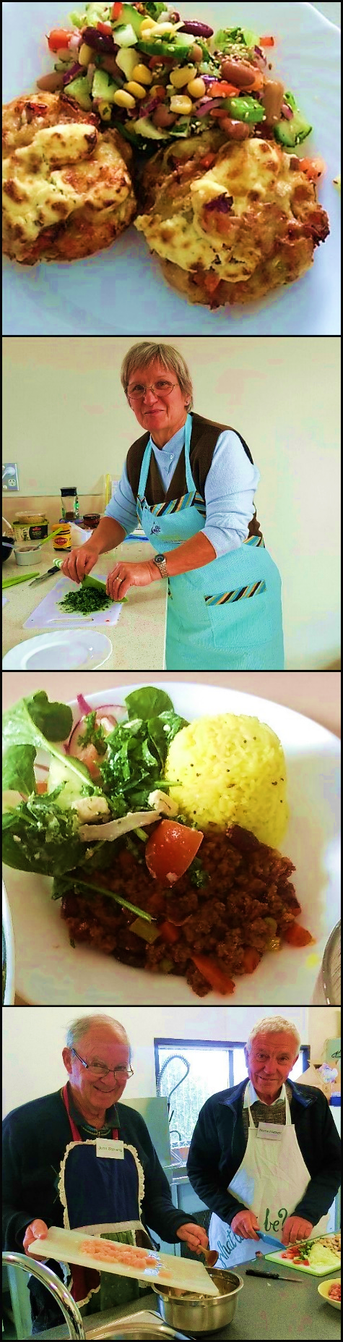
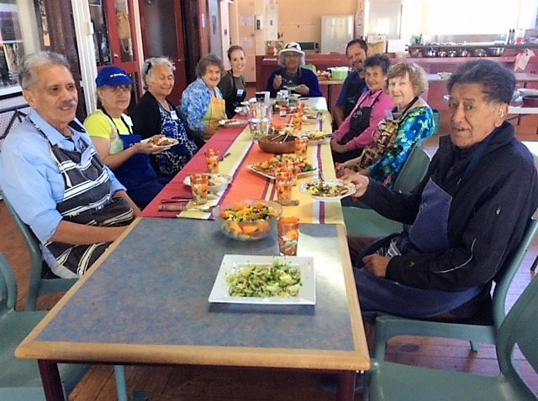
Ageing

Healthy

JUST COOK Healthy Ageing Programme Outline
The Just Cook Healthy Ageing Programme is a 4-week programme for people over the age of 67 who want to be inspired to cook healthy, simple meals for 1 or 2 people. The programme focuses on building cooking skills and motivation to cook.
The 3 hour class includes
- nutrition education
- cooking and sharing a meal together
- socialisation
Topic | Cooking
Eat Well Age Well  - Food Myths associated with Ageing  - Changes associated with ageing  - Food and Nutrition Guidelines for older people. Four main food groups  - Sustainable food practices  - Ready Steady Cook, Cookery terms | Tuna & Vegetable Frittata (demonstration)  Savoury Muffin Quiches with Seasonal Salad
Planning Delicious Healthy Meals  - What should a healthy meal plate look like?  - Portion Size guide  - Healthy ingredient swaps | Chilli Con Carne with Mexican Salsa Salad and Rice  Chicken stir fry with basmati rice (demonstration)
Smart Shopping, clever cooking  - Tips to stretch your food budget  - Making meat go further  - Sprucing up the staples  - Meal planning  - Food storage | Thai Kumara & Pumpkin Lentil Soup with Croutons/toasted Pita Bread ( demonstration)  Potato Topped Tuna mini pies with frozen steamed beans
Details of next programme
not yet confirmed.
Enquiries: sallyrees02@gmail.com
Ph: 0211709443

