Date: 19 September 2022 (Newsletter)

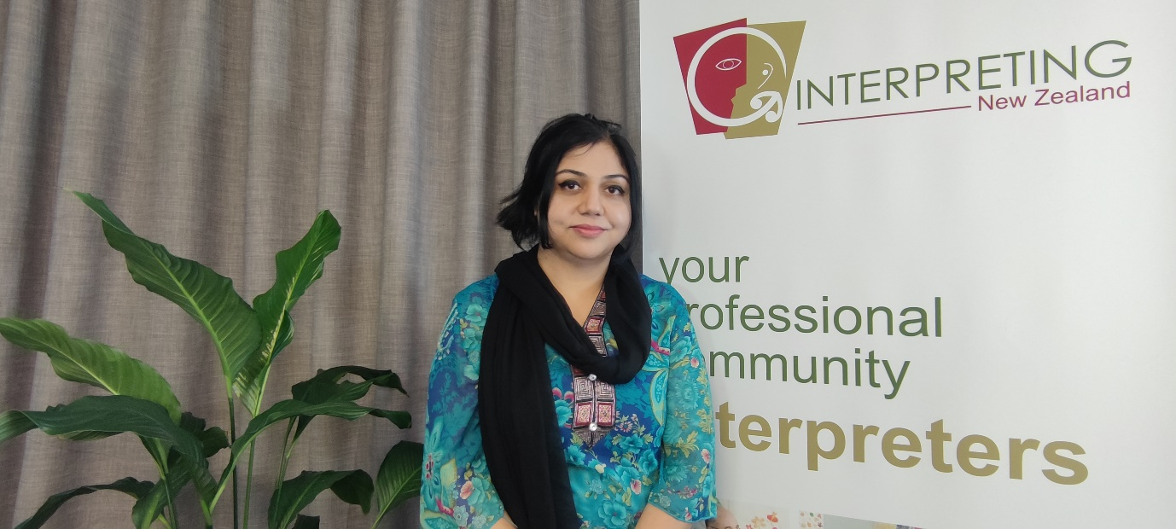

Kia Ora,

My name is Sanam Mukhtar and I am the Regional Manager of Interpreting New Zealand for Nelson Marlborough. Today, I am writing to introduce Interpreting New Zealand to the wider community. Interpreting New Zealand is a not-for-profit incorporated society operating across New Zealand. It was established in 1993 as the Wellington Community Interpreting Service. We are a social enterprise (not government-funded), so we charge fees for providing interpreters, allowing us to keep investing in training. Interpreting NZ strives for people in New Zealand to have access to interpreting services of the highest professional and ethical standards.

Our code of ethics and quality standards make us different from the other providers. We do not compromise on quality and run an annual evaluation that allows our customers to evaluate each and every on-site job that takes place in that particular month of the evaluation period. So far, our customer satisfaction results look great. We do it every year to improve our services and tailor the training opportunities for our interpreters to improve.

We offer:

- 24-hour, 7-day a week accessibility, including public holidays
- a pool of trained, New Zealand-based interpreters who are familiar with local agencies, nuances of language and ways of working
- approximately 75 community languages including New Zealand Sign Language
- interpreters bound by a Code of Ethics ensuring confidentiality, impartiality and accuracy
- on-site interpreting, particularly but not exclusively, in Wellington, Nelson, Christchurch, Dunedin and Auckland
- telephone or video conference interpreting
- interpreters independent of both the user agency and the speaker of the language other than English
- mandatory, comprehensive and high-quality training and assessment for all prospective interpreters
- monitoring of the performance of the interpreters and provision of ongoing professional development
- well-established community networks which enable the most culturally appropriate interpreter to be chosen for each situation
- training for professionals in the effective use of interpreters

I am here to help. Please reach out to me if you need further information. I am happy to share more details with you.

Best Regards,

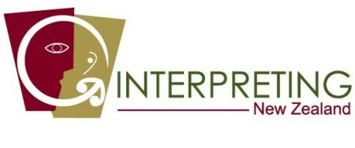
SANAM MUKHTAR
Nelson Regional Manager
M: 022 412 0163 | Toll free: 0508 468 377
Level 1, 72 Abel Smith Street | Wellington | 6041
www.interpret.org.nz

