Michael’s Aldridge Success through partnership of Workbridge and Volunteer Nelson written by Nicola Zielinski
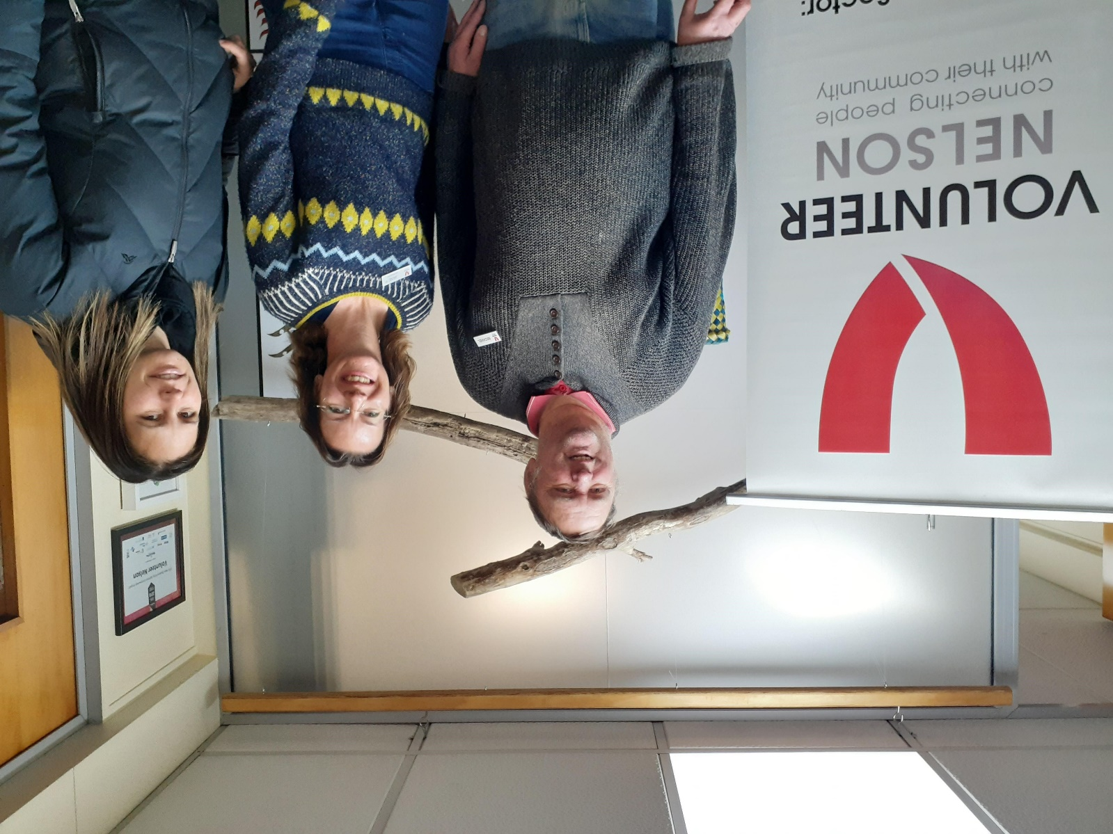

Michael registered with Workbridge in May 2019 and has been on an incredible journey eventually finding work with the very well-known Volunteer Nelson based in Buxton Square carpark.

It was always apparent from day one that Michael was a very committed and loyal citizen in our local community, he supports local businesses such as the State Cinema for his love of films, he enjoys a cup of coffee whenever he gets the chance with his support workers and he even supports the environment by cycling to all of his appointments.

In his spare time, he helped as a volunteer with the city’s hanging baskets down at Nelmac Nursery and year on year Michael volunteers his time for People First giving those with a disability a voice. Occasionally Michael travels to Wellington for this.

Michael has been on a great path of development working on job application skills and personal skills for the world of work.

Nicola Zielinski of Workbridge said “Michael always turned up on time for his appointments and took everything on board from checking emails, ensuring mobile phone was charged in case he got the call with a job offer to dressing smartly and getting a hair cut for his job interviews”

Michael lives with an intellectual disability, this in simple terms means processing information can take a little longer for Michael. He was assisted in his appointments by Pete Bywater from Ideas Services. Pete supported Michael in some of his key decision-making processes and ensuring priorities were put in place to balance life with work.

In March 2020, around 9 months after enrolling with Workbridge, Michael wowed the team at Volunteer Nelson with his cleaning skills so much, so they offered him a paid position as their cleaner. Nicola Zielinski supported in his first shift ensuring Michael was able to follow the simple checklist with all the rooms that he was to clean.

Jane Solly of Volunteer Nelson was a great support and really took on board Michael’s needs and abilities. Jane provided regular feedback to Workbridge on Michael’s progress and it is great to see he is blossoming in the role.

Unfortunately, like many other workers during Covid19 lockdown Michael had to press pause on his duties whilst the offices were closed however, he is keen and eager to get back to work once he can.

