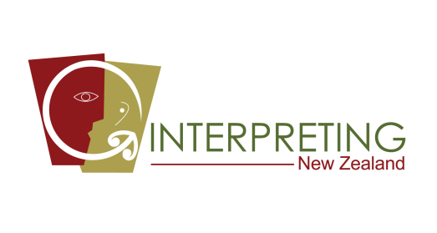
Date: 18th July, 2021

Kia Ora Nelson,

If you’re bilingual, are you interested in using your language skills and earn some money in your spare time?
We are looking for people who can speak English and any of the below languages:
- Burmese
- Cantonese
- Chin Hakha
- Karenni
- Kayan
- Khmer (Cambodian)
- Korean
- Mandarin
- Samoan
- Tagalog
- Thai
- Turkish
Please apply for Nelson region by filling out an online form:

https://interpret.org.nz/application-form.html

Let me know if you have questions- it would be my pleasure to respond. I look forward to hearing from you.

My contact details are:

Sanam Mukhtar

Email: nelson@interpret.org.nz
Call/SMS: 022 412 0163

