**COMMUNITY MATTERS**

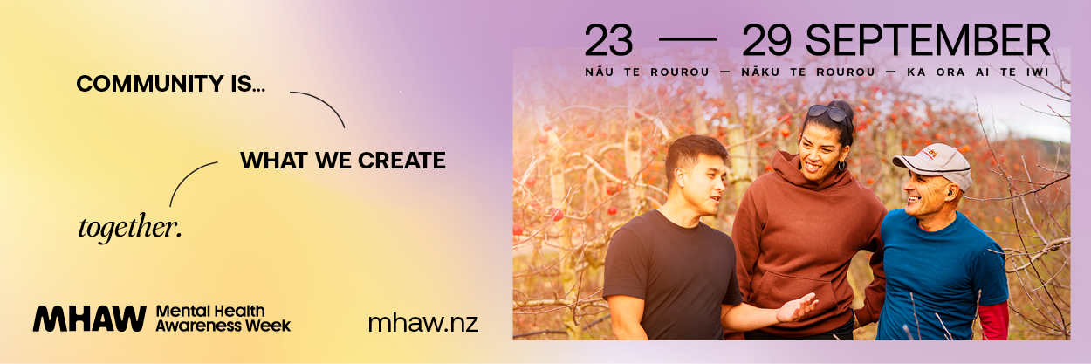

**COMMUNITY IS………. THRIVING TOGETHER THROUGH UNCERTAINTY**

