**Job Title: Production Assistant, Homefullness Show on Podcast & YouTube**

**Location:** Remote. Ideally in a time zone with at least 2 hours overlap with NZ work-week days.

**Type:** Part-Time / Volunteer/Future paid role (4–8 hours per week to start)

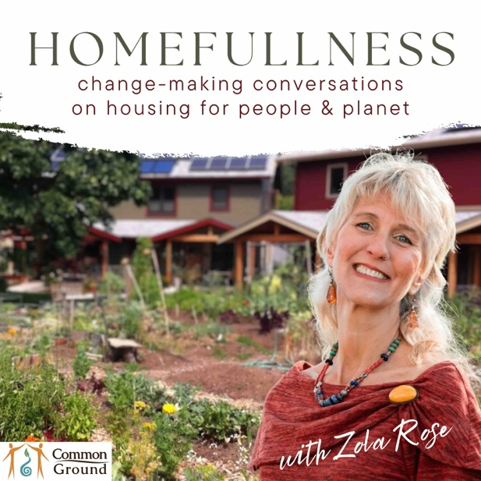**About the Homefullness Show:**

Homefullness is a show dedicated to exploring innovative and regenerative approaches to housing in Aotearoa New Zealand and beyond. It empowers individuals, community leaders, and housing professionals with the knowledge and tools to help create affordable, connected, and resilient neighbourhoods.

The show covers a diverse range of topics, including alternative housing models, neighbourhood design, and innovations in energy, water, waste, construction, land use, and food systems. It also showcases housing policies, finance, and funding strategies that support better housing solutions.

By providing real case studies and highlighting critical research, Homefullness fills a crucial gap in public knowledge and aims to inspire sustainable and thriving housing projects.

Find the show on any podcast app, the Common Ground YouTube channel, and at this page: https://www.commonground.net.nz/show

**Role Overview:**

We are seeking a detail-oriented, technically skilled Production Assistant to support the behind-the-scenes production and promotion of the Homefullness show. The role is ideal for someone passionate about housing and community issues, who enjoys editing content, promoting stories, and helping a show grow its audience and funding.

This role focuses primarily on technical production tasks, with additional responsibilities in promotions, guest coordination, and fundraising support.

**Key Responsibilities:**

* Edit audio and video content using Descript for podcast and YouTube publication.
* Create engaging video clips and shorts for social media.
* Design thumbnails and promotional graphics using Canva.
* Assist with episode scheduling and guest communication.
* Upload content to podcast and video platforms with accurate descriptions and tags.
* Help promote the show and episodes through social media and other digital channels.
* Support the growth of the Patreon community through updates, campaigns, and donation prompts.
* Assist with sponsorship outreach: identifying aligned businesses and following up on leads.
* Track basic performance analytics to help guide promotional efforts.
* Assistance with merchandise: the procurement from suppliers and distribution on Patreon.

**Experience and Skills:**

* Passion for the Homefullness mission and an interest in housing, community, or sustainability issues.
* Some experience with podcast or YouTube production.
* Proficiency with Descript (or willingness to learn quickly).
* Basic graphic design skills using Canva.
* Comfortable using social media and understanding content engagement strategies.
* Strong written and verbal communication.
* Self-motivated, reliable, and organized.

**Hours:**

Approximately 4–8 hours per week to start, with potential to grow to 10-12 hours per week as a paid role as the show expands and funding increases.

**Note on Compensation:**

This is a volunteer position to start, with no remuneration until funding and sponsorship are secured. That means we’re looking for someone who is genuinely passionate about the mission of Homefullness—using media to drive positive change in housing systems and neighbourhood design.

Sponsorship and Patreon funding are already in the pipeline, and the better the content and audience engagement, the more likely these income streams will be realized. Common Ground aims to pay a fair hourly wage and potentially offer other benefits once funding is in place such as free access to events and free or discounted merch.

**What’s In It for You:**

* A chance to work on a meaningful and impactful project that addresses real-world housing and community challenges.
* Gain hands-on experience in audio and video editing, digital media production, and content marketing.
* Build your portfolio with professional-level podcast and YouTube content.
* Learn about innovative housing models and sustainable neighbourhood design.
* Develop your skills in platforms like Descript, Canva, and Patreon.
* Connect with thought leaders, changemakers, and creatives in housing and sustainability.
* Potential for future paid work as funding and sponsorship are secured and to work on bigger projects.
* Complimentary access to Common Ground events and merchandise

**How to Apply:**

To apply, please send your CV and a 1-page cover letter describing your interest and relevant experience to [zola@commonground.net.nz](mailto:zola@commonground.net.nz).

Applications close at end of day on 30 June but we will be assessing applications as they come in so be sure to apply early.

You can call Zola with any questions to 027-449-0422.

If you’ve worked on podcast or YouTube content before, feel free to include links.

Join us in telling the stories that can help reimagine, catalyse, and fuel housing for people, the planet, and future generations.