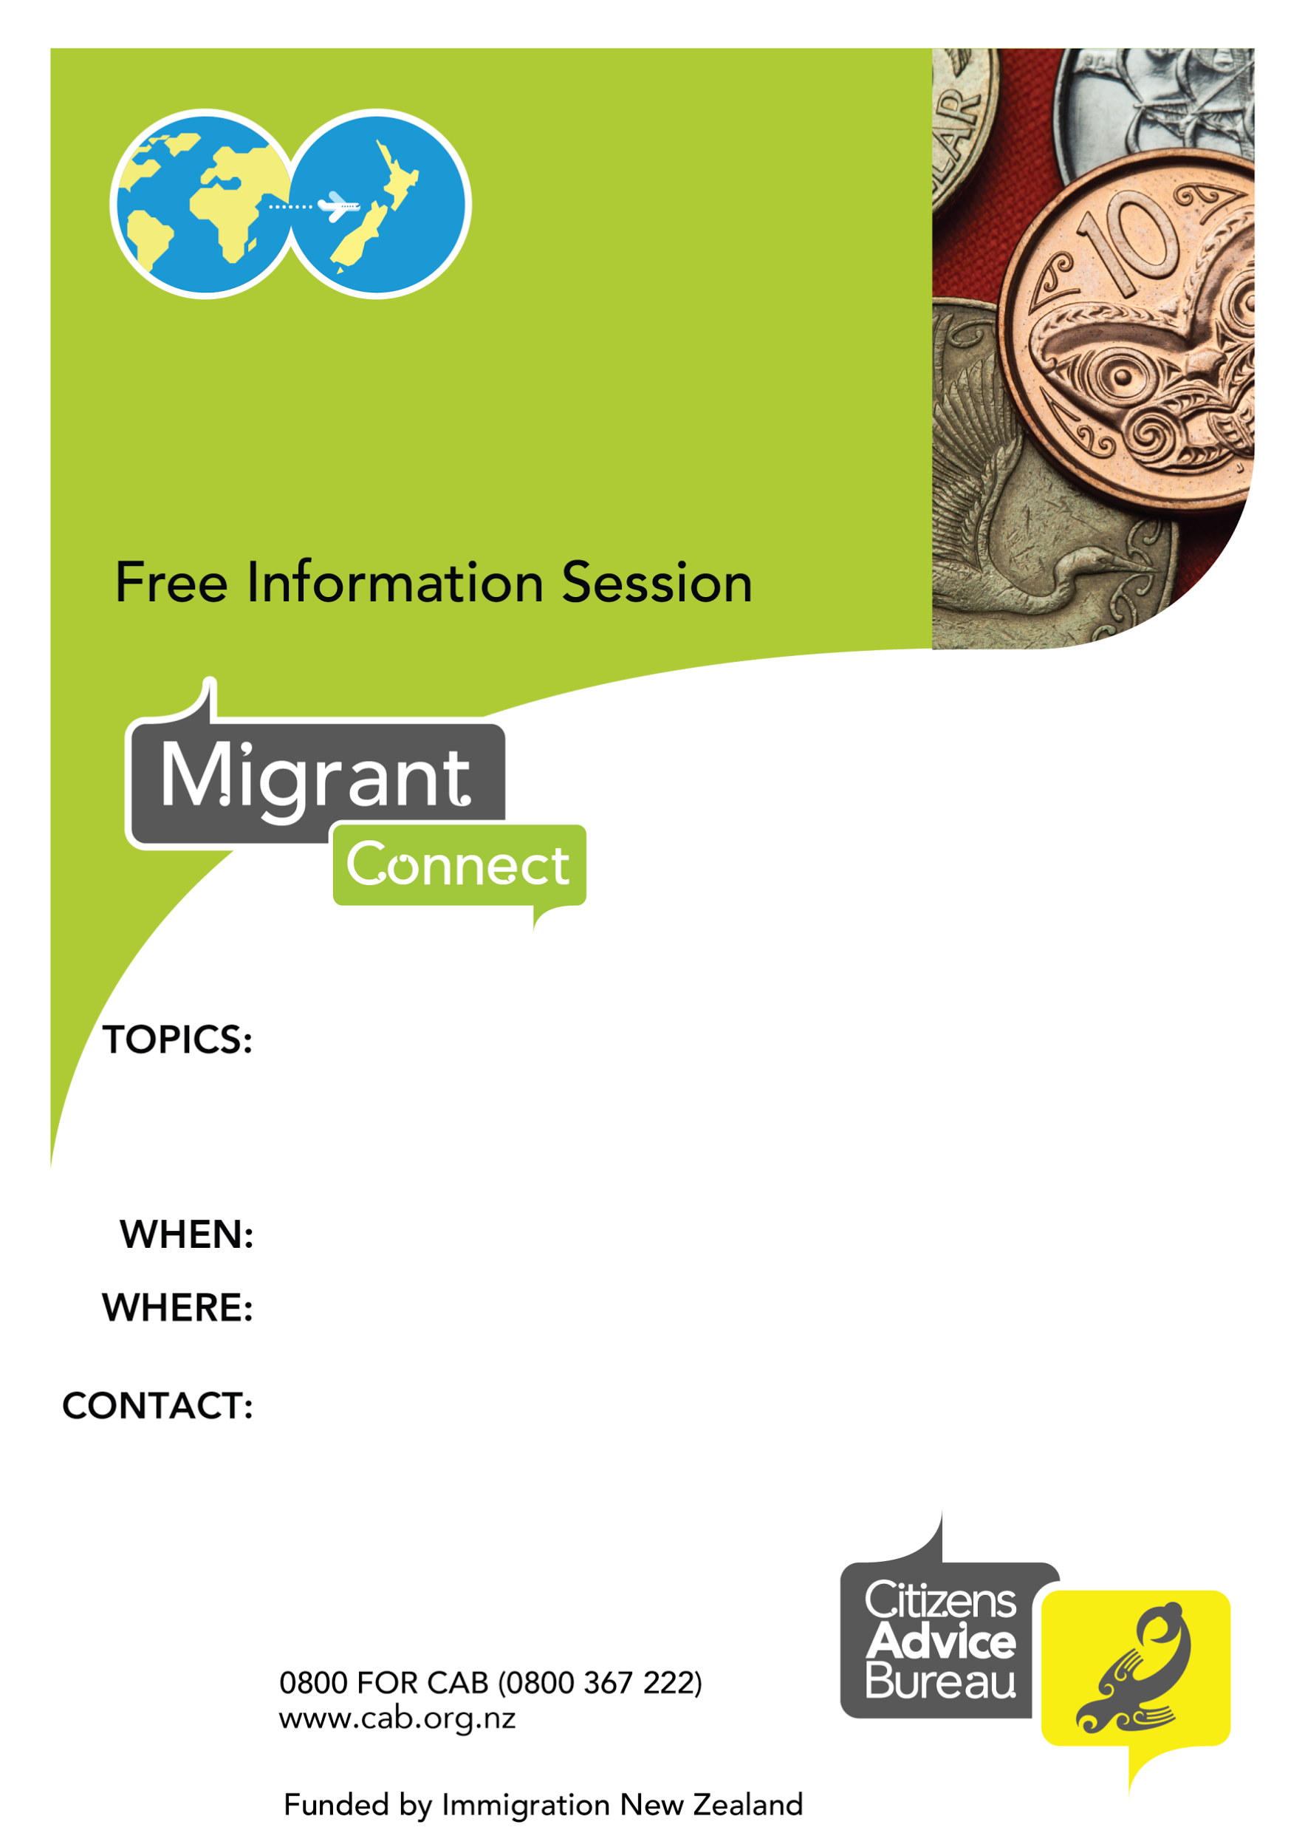

Citizen Advice Training Room: 9 Paru Paru Rd, Nelson

Numbers limited so please register with details below.

**Introduction to General Insurance in NZ**

NEW ZEALAND

Introduction into General Insurance.

Includes: what is insurance, how does it work, car, household, travel, companies, insurance terms, what to do when things go wrong.

3.30pm 24th February 2021

Citizens Advice Bureau Nelson Tasman

offer free, face to face support to new migrants.

Contact details.

Megan Cole: coordinator.nelsontasman@cab.org.nz

03 548 2117