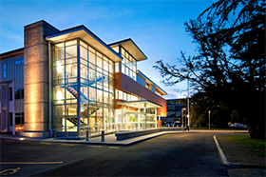

**You are warmly invited to a Family Court event with presentations by**

**Lawyer for Child - What do they do?**

[**OurFamilyWizard | The Best Coparenting App**](https://www.ourfamilywizard.co.nz/)

Friday 24 May 2024 1pm – 3.30pm

Nelson District Court House

200 Bridge Street

**1pm** Meet outside the Court House and we will.

head through Court Security and upstairs to

Court room 1.04

**1.15pm – 2.15 pm** Lawyer for Child presenters are:

Belinda Fletcher ,Jessica Gully & Heather McKinnon

**2.15 pm – pm** Our Family Wizard presenter:

Timothy McMichael

**3pm -3.30pm** Mix and mingle with light refreshments.

**RSVP** [felicity.hurst@justice.govt.nz](mailto:felicity.hurst@justice.govt.nz)