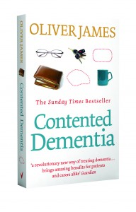
Contented Dementia

Supporting someone with Dementia?
This is not to be missed!!

Alzheimers Nelson is delighted to introduce
Janion Heywood who will be speaking
at the Saxton Oval on Wed 19th June 2019
1.30pm-2.30pm

A drug less system of caring for people with dementia which enables the person to live contentedly with a lifelong disability, rather than disintegrate
with an ultimately fatal illness.
It is a programme designed to be used at home, and focuses as much
on the primary carer and the family and community, as it does
on the person with dementia, thus giving everyone new skills,
new coping strategies and the chance for contentment, rather than burnout.
It is simple, and requires some work, but is oh so rewarding!
This talk will introduce you to the Photograph Album and the Three Golden Rules.
The idea is you will understand what it is like to have dementia, and be able to let go of concepts of remembering and forgetting.

Biography: Janion describes herself as a retired doctor and full-time human being.
She believes that wellness is more fun than illness, and people are more interesting than their diseases.
She dreams of a true Health based system rather than our current illness system and does not subscribe to the belief that there is a pill for every ill, but there may well be a plant or food for treating for most of them!
For the last 10 years of her practicing she cared for up to 32 people in a Continuing Care Facility and loves the older people and their amazing life stories.
She believes people with dementia are not absent, they are simply present somewhere else. Janion was born and trained in England but has been in New Zealand for 36 years, so feels like a kiwi, though she understands she still sounds very English!

