Art Flags Entry Form
Official use only

Artist Name: Email: ____________________________________

Phone: Town/Area of residence: _____________________

Entry # 1 Title (if any) ______________________________________________________________

Entry # 2 Title (if any) ______________________________________________________________

Entries by artists under 18 years old require consent from a parent / caregiver. If appropriate, please complete this section of the entry form.
Name of parent / caregiver: ________________________________ Age of artist: ___________
Relationship to artist: ____________________________
Contact phone & email if different to above: ____________________________________________
I understand the terms and conditions and hereby consent for this entry to be considered for the Art Flags Project. I confirm that I have the artist permission to receive any remuneration on their behalf should their design be selected for this project.
Signature of parent/caregiver: ________________________________________

Checklist:
- I attach a copy of my design proposal which adheres to the required format
- I have put my name on the back of my submitted image
- I would like my image copy returned to me and attach a SAE for this purpose
- If selected, I am able to supply a high res image of my design
I understand and agree to the terms and conditions of entry.
Signed by the Artist:___________________________

All entries must reach Arts Council Nelson at the Refinery ArtSpace, 3, Halifax Street, Nelson by 4pm on Monday 23rd September 2019. Hours: Mon – Fri 10 – 5pm, Saturday 11 – 2pm.
Late entries will not be considered.
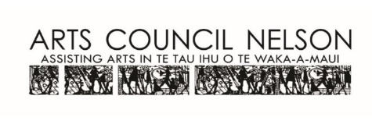
For any further queries please contact Lloyd Harwood at Arts Council Nelson. Ph: (03) 548 4640 or email artscouncilnsn@gmail.com

