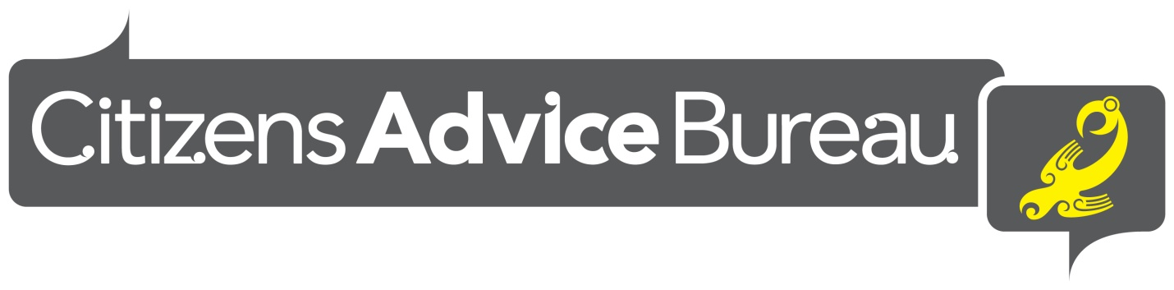
Are you interested in further learning? Are you empathetic, have an interest in helping people learn about their rights and responsibilities, are you interested in belonging to a professional, kind and caring work environment?
The Citizen Advice Bureau is currently recruiting for volunteers for becoming interviewers at our Bureau in Nelson.
Training begins March 2022
For further information please contact the Manager, Megan Cole on 03 548 2117, email: coordinator.nelsontasman@cab.org.nz or pop into the Bureau at 9 Paru Paru Rd, Nelson for further information.
You can also visit our website: www.cab.org.nz

