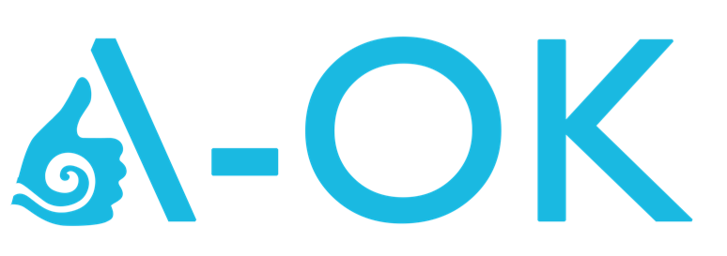
Acts of Kindness that saves lives
www.a-ok.nz
www.suicidefirstaid.nz

A-OK suicide intervention training, is a provider of suicide intervention skills training.
We believe everyone can play a significant role in preventing suicide. We provide quality, safe and very practical training that anyone can use.

Most organisation have physical first aid skills to be able to keep people alive when they are physical struggling. Suicide first aid skills are also needed to help keep people alive when they are emotionally and mentally struggling.

1 in 20 could be thinking about suicide

What that means is they are looking for help. They have had some struggles in life, that have caused them to feel helpful, hopeless and in need of some kind of help.

Most people thinking about suicide, can talk themselves out of it.

They just need someone who can help them through this.

You could be that source of help.

We offer three workshops across the country both in public training schedules and can also offer them inhouse to suit your business learning needs.

Safetalk – half day training to help people learn how to recognise someone in need of help and how to start a caring conversation that could help guide this person to safety.
www.a-ok.nz/safetalk

ASIST – 2 day practice suicide intervention training. A very practical workshop for people who would like to feel willing, ready and able to keep people safe from suicide.
www.a-ok.nz/asist

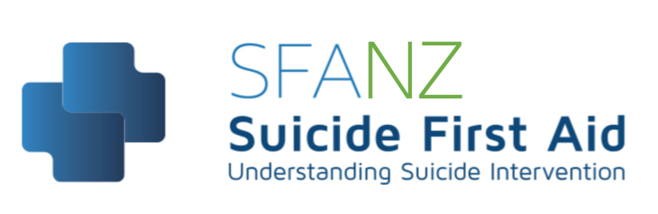
Suicide first aid training – 1 day suicide first aid intervention skills training
www.suicidefirstaid.nz

