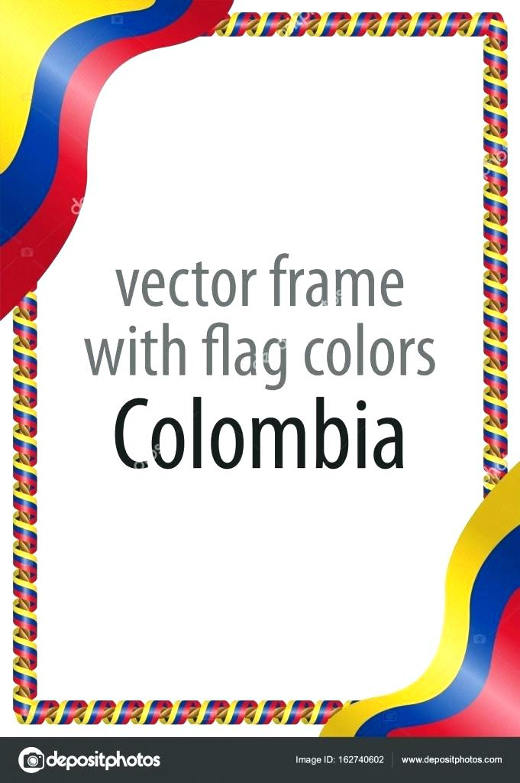

**Colombian Cultural Celebration**

**Colombian cuisine and culture at Founder's Heritage Park.**

[87 Atawhai Drive, The Wood, Nelson](https://maps.google.com/?q=87+Atawhai+Drive,+The+Wood,+Nelson+7010&entry=gmail&source=g)

**Saturday, 11th of August 2018**

**10am- 4pm**

Restriction: All ages are warmly welcome

Ticket info: Free entry

A family fun day revolving around the rich and highly diverse Colombian Culture. Food, Sports, and Arts will be presented.

The Colombian community is a recent and fast-growing addition to the diverse cultural makeup of the region. This event aims to preserve their Latin American heritage as well as sharing it and integrating the many cultures of Nelson/Tasman.

Traditional food from the varied regions of Colombia will be sold, summing up a total of approximately 20 dishes. Football matches will be held for people to join or spectate. Artistry will also be shown, traditional dances, crafts and audio-visual expositions.

Come and enjoy this wonderful Colombian cultural experience.