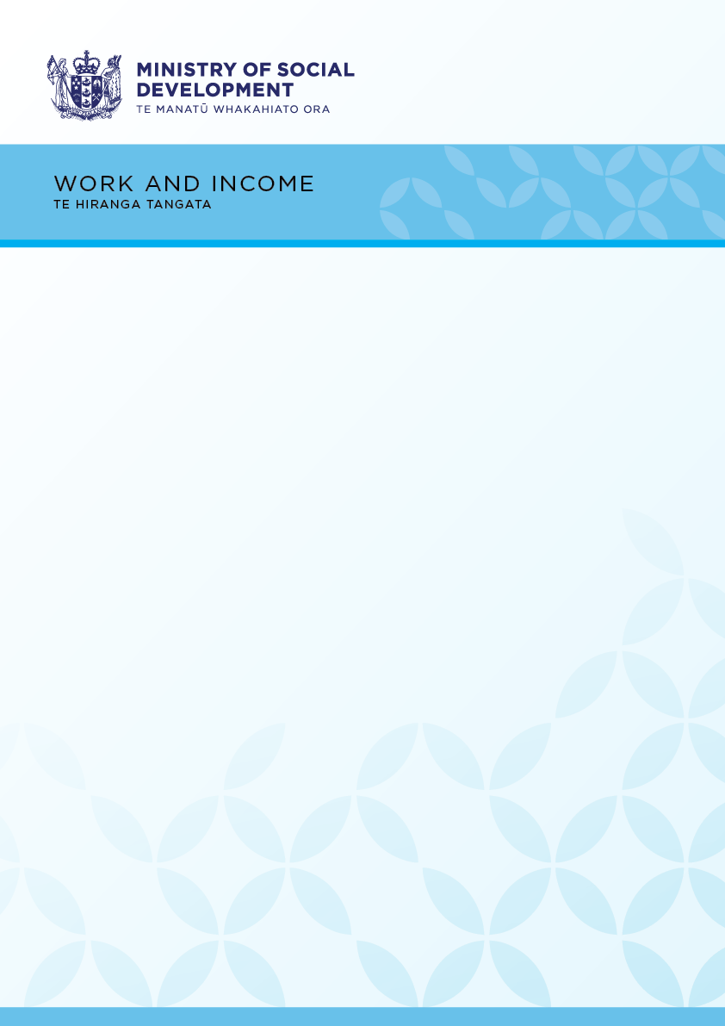

Kia ora!

We’re making improvements to the Work and Income service centre on Bridge Street!

To get things done as quickly as possible, we’ll be **closed** temporarily for six weeks:

**from 5pm on 1 September 2022,**

**reopening 8:30am on 18 October 2022**

We’re looking forward to welcoming you back!

If you need help, you can still get in touch with us.

* Call 0800 559 009 for Work and Income
* Call 0800 552 002 for Senior Services
* Visit my.msd.govt.nz
* Visit Connected.govt.nz

Thanks so much for your patience.